Data modeling
- Star model:
A star schema is a simple and effective structure to design a database model which consists of a fact table and several dimensional tables. One important factor between fact and dimensional tables is that they must have at least one common (primary key) column to map between two tables. The fact table holds important data which is measurable. Similarly, dimension tables add context to the data. For instance, dim_officer contains officer names with unique IDs, and fact tables can use unique id which is more effective in two ways.

- A unique id is int and an integer holds less space than the varchar.
- Easy to maintain using indexing and retrieve using joins.

Some limitations of the model:
With the increase in data, volume could be a challenge. If the fact table grows then the query performance will be slow and may need additional strategy to tune performance. Changes in the business rules can impact the whole process of working.
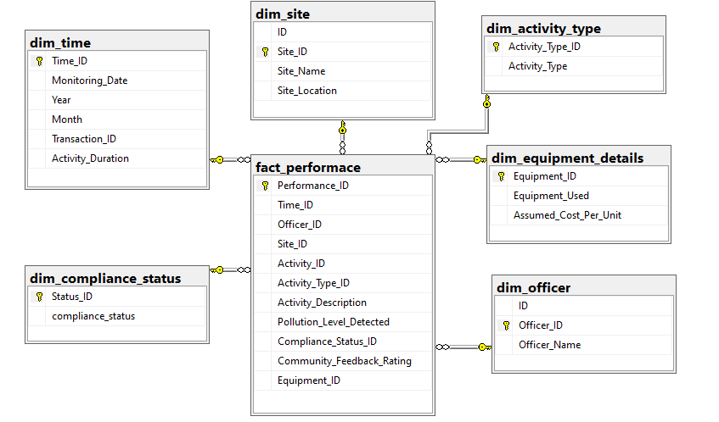
- Fact Table (fact_performance):
This table contains the quantitative data that belongs to the officer activities performed at different locations. Some important metrics are community feedback, activity duration, pollution levels
- Dimension Tables:
Dim_officer: This table contains the unique officer name and their IDs.
Dim_site: This table contains the distinct site name and site ID.
Dim_activity_type: This table categorizes the types of activities.
Dim_compliance_status: The table supports tracking whether the officer activities meet the working standards
Dim_equipment_details: This table has a distinct list of equipment.
Dim_time: This table allows us to analyze different time periods (yearly, monthly, daily).

Data Types
COLUMN_NAME | DATA_TYPE | CONSTRAINT
Monitoring_Date | date | not null, yyyy-MM-dd
Officer_ID | int | not null
Site_ID | int | not null
Officer_Name | varchar(50) | not null
Site_Name | varchar(100) | null
Site_Location | varchar(100) | null
Activity_ID | int | not null
Activity_Type | varchar(100) | not null
Activity_Description | varchar(100) | not null
Activity_Duration | decimal(16,4) | not null
Equipment_Used | varchar(50) | not null
Pollution_Level_Detected | decimal(16,4) | not null
Compliance_Status | varchar(50) | not null
Community_Feedback_Rating | int | not null,  [Community_Feedback_Rating]>=(1) AND [Community_Feedback_Rating]<=(5)
Transaction_ID | int | not null

ETL
For ETL process, we used SQL server import and export feature of sql server management studio.
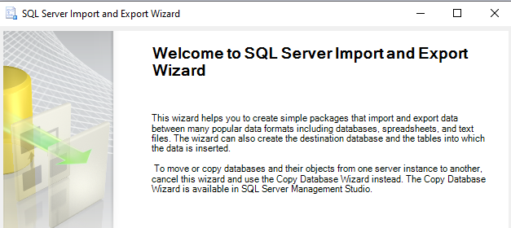

Since the source file was in Excel, we tried to import the data using the source file as Excel and the destination as SQL server but unfortunately, SSMS did not support Excel to read the data. Below is the issue we faced while trying to load Excel file.
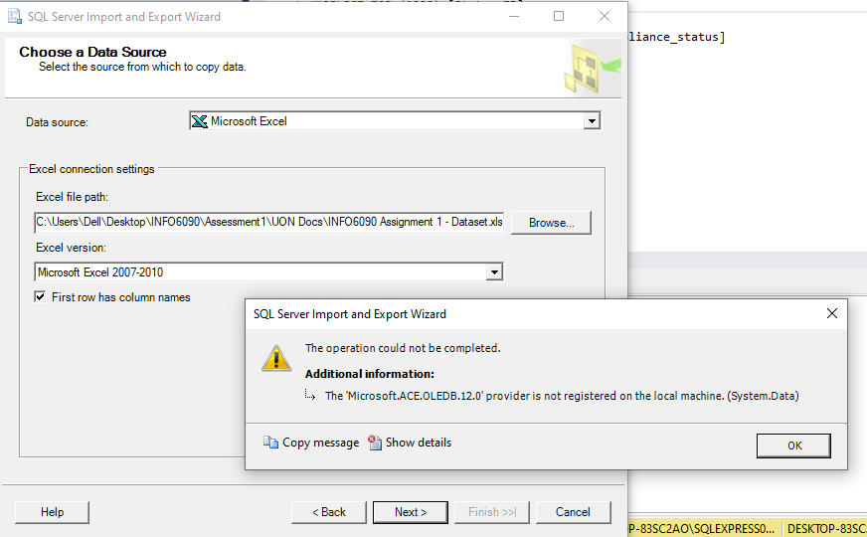

We looked for an alternative solution converted the Excel file to CSV and loaded the client’s data into the database.
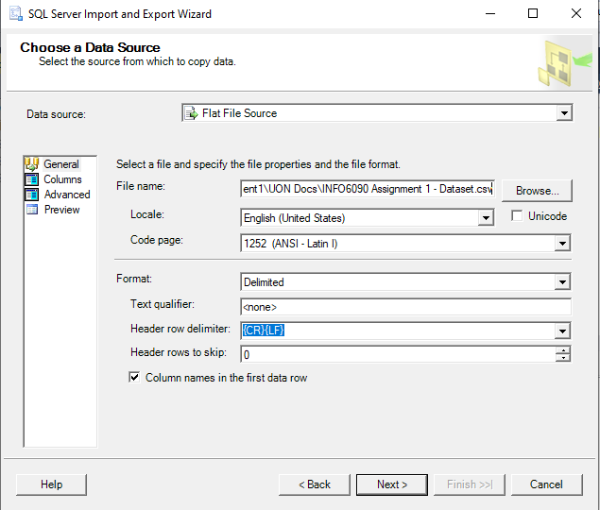
We loaded the CSV data into the physical temporary table (table name = INFO6090 Assignment 1 – Dataset). Then we used cases and conditions to data format to move the raw data into the staging table (table name = dbo.SourceData). Below is the insert query to migrate data to staging with data transformation conditions.

insert into [SourceData]
(Monitoring_Date, Officer_ID, Officer_Name, Site_ID, Site_Name, Site_Location, Activity_ID, Activity_Type, Activity_Description,
Activity_Duration, Equipment_Used, Pollution_Level_Detected, Compliance_Status, Community_Feedback_Rating, Transaction_ID)
SELECT
Monitoring_Date = convert(date,[Monitoring Date]),
Officer_ID = convert(int,[Officer ID]),
Officer_Name = convert(varchar(100),[Officer Name]),
Site_ID = convert(int,[Site ID]),
Site_Name = convert(varchar(100),[Site Name]),
Site_Location = convert(varchar(100),[Site Location]),
Activity_ID = convert(int,[Activity ID]),
Activity_Type = convert(varchar(100),[Activity Type]),
Activity_Description = convert(varchar(100),[Activity Description]),
Activity_Duration = convert(decimal(16,4),[Activity Duration (hours)]),
Equipment_Used = convert(varchar(100),[Equipment Used]),
Pollution_Level_Detected = convert(decimal(16,4),[Pollution Level Detected]),
Compliance_Status = convert(varchar(100),[Compliance Status]),
Community_Feedback_Rating = convert(int,[Community Feedback Rating]),
Transaction_ID = convert(int,[Transaction ID])
FROM [INFO6090_Assignment].[dbo].[INFO6090 Assignment 1 - Dataset]

After this, we analyzed the staging data and found some duplicate IDs for the officer name and site name. We made a few assumptions and cleaned the data accordingly.

Assumptions:
- The file contains 25 unique officer ids (1 to 25). We have assigned this unique ID to a unique officer name in alphabetical order. This is the case for officer details. As shown in the screenshot below, the officer ID for ‘Uma Allen’ is multiple in the source data but after the assumption and cleaning of the data, there is only one officer ID for ‘Uma Allen’.
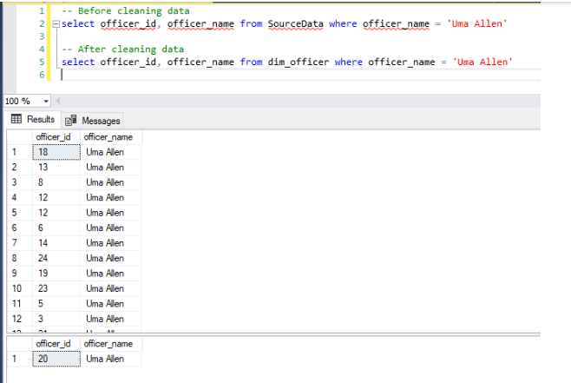
- The file contains 24 distinct site IDs and 23 distinct site names. We have assigned 23 unique site IDs to 23 unique site names randomly but for one site id, the site name will be null. This is the case for site details. As shown in the screenshot below, the site ID for ‘Lambton Park’ is multiple in the source data but after assumption and cleaning data, there is only one site ID for ‘Lambton Park’.
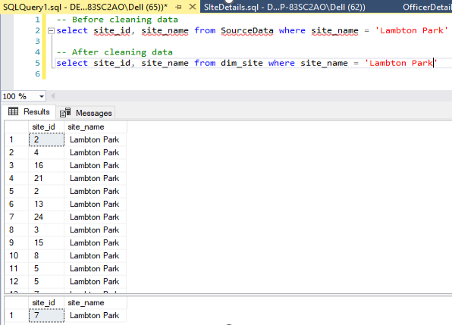
- We have provided a random price for the equipment.
These assumptions are considered without hampering other columns in the source data.

After this, we created the fact and dimension tables and then moved all the data from staging table (SourceData) to their respective dimensional and fact table.

Basic flow diagram:

SQL Scripts
For KPIs calculation,
CREATE view [dbo].[vw_performance_metric_collection]
as
select qry.*,tc.TotalCostByOfficer from (
SELECT Officer_ID,max(officer_name) as Officer_Name,
COUNT(Activity_ID) AS TotalActivities,
AVG(Activity_Duration) AS AvgDuration,
AVG(Community_Feedback_Rating) AS AvgFeedback,
SUM(CASE WHEN compliance_status = 'Compliant' THEN 1 ELSE 0 END) * 1.0 / COUNT(Activity_ID) * 100 AS ComplianceRate,
avg(a.Pollution_Level_Detected) avg_pollution_level

FROM [vw_performance_details_all] a
GROUP BY Officer_ID
) qry inner join vw_TotalCostByOfficer tc on qry.Officer_ID = tc.officer_id

For ranking officer
WITH RankedOfficers AS (
SELECT
Officer_ID,
Officer_Name,
TotalActivities,
AvgDuration,
AvgFeedback,
ComplianceRate,
avg_pollution_level,
TotalCostByOfficer,
RANK() OVER (ORDER BY TotalActivities DESC) AS ActivityRank,
RANK() OVER (ORDER BY AvgDuration ASC) AS DurationRank,
RANK() OVER (ORDER BY AvgFeedback DESC) AS FeedbackRank,
RANK() OVER (ORDER BY ComplianceRate DESC) AS ComplianceRank,
RANK() OVER (ORDER BY avg_pollution_level ASC) AS PollutionRank,
RANK() OVER (ORDER BY TotalCostByOfficer ASC) AS CostRank
FROM vw_performance_metric_collection
),
TotalPoints AS (
SELECT
*,
(ActivityRank + DurationRank + FeedbackRank + ComplianceRank + PollutionRank + CostRank) AS TotalPoints,
ROW_NUMBER() OVER (ORDER BY (ActivityRank + DurationRank + FeedbackRank + ComplianceRank + PollutionRank + CostRank)) AS Rankk
FROM RankedOfficers
)

SELECT
a.Officer_ID,
a.Officer_Name,
a.TotalActivities,
a.AvgDuration,
a.AvgFeedback,
a.ComplianceRate,
a.avg_pollution_level,
a.TotalCostByOfficer,
a.ActivityRank,
a.DurationRank,
a.FeedbackRank,
a.ComplianceRank,
a.PollutionRank,
a.CostRank,
b.Rankk
FROM RankedOfficers a
JOIN TotalPoints b ON a.Officer_ID = b.Officer_ID
--ORDER BY b.Rankk;
GO

